-------------------------------------------------------------------------------------------------------------------------------NAME: ARCHANA DEVI.P
REG NO: 192521192
COURSE: SOFTWARE TESTING
CODE: CSA0923
LAB PROGRAMS
Question 20: Count Vowels and Consonants Using JUnit

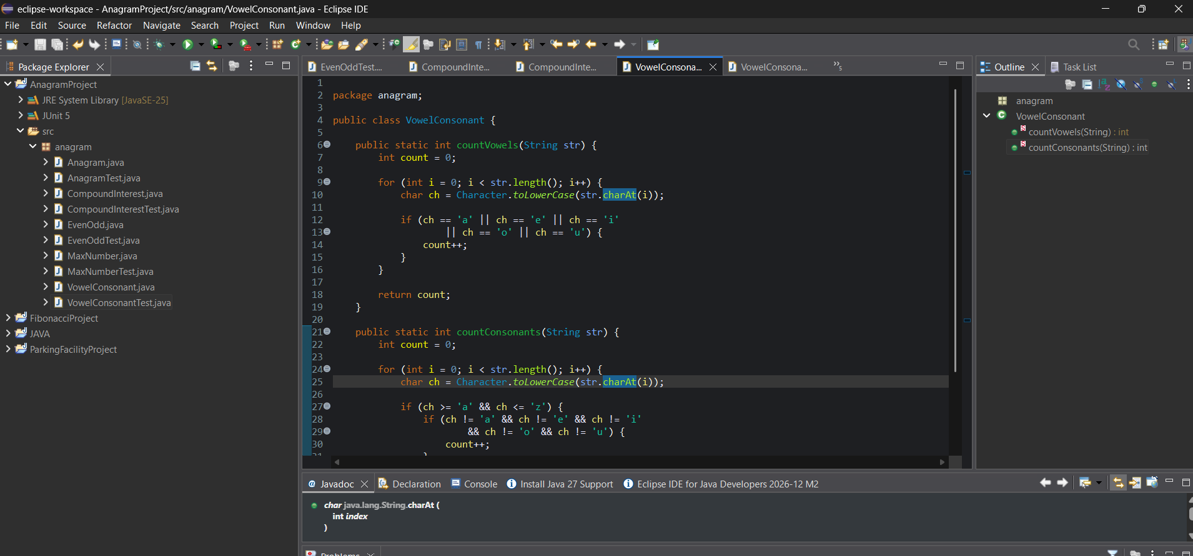

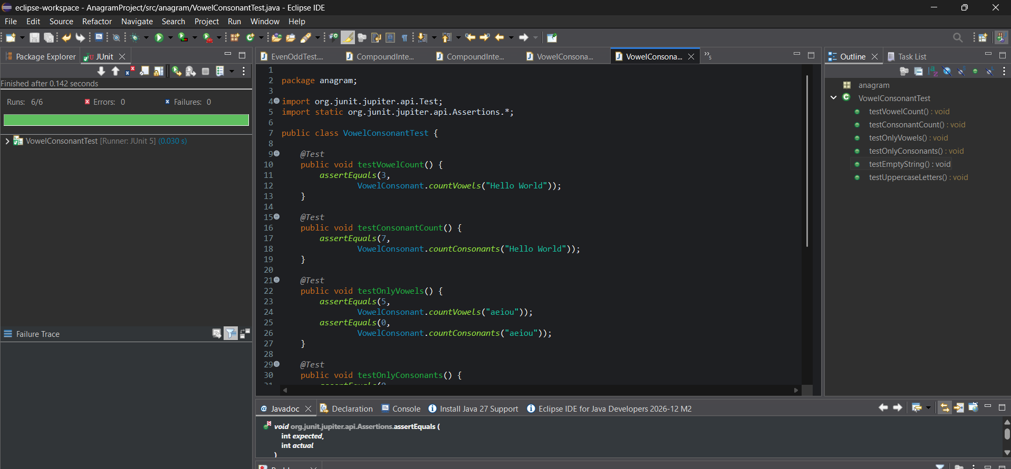

White-box testing
The program uses loops and conditional statements, so test cases should cover different paths.
Test input | Expected vowels | Expected consonants
Hello World | 3 | 7
aeiou | 5 | 0
bcdfg | 0 | 5
Empty string | 0 | 0
JAVA | 2 | 2

The test cases cover the vowel condition, consonant condition, uppercase conversion, loop execution, and empty input.
Result: The Java program successfully counts vowels and consonants in a given string. Six JUnit test cases were designed to validate different inputs and execution paths. All six tests should pass when executed successfully.

